

Lab # 03
Information Security
Instructor: Sir Anayat Ullah

Student Name: | Muhammad Abdullah
Registration No: | FA24-BSE-042
Department: | Software Engineering
Submission Date: | 17 march 2026

COMSATS University Islamabad

ACTIVITY 1:
TASK1:
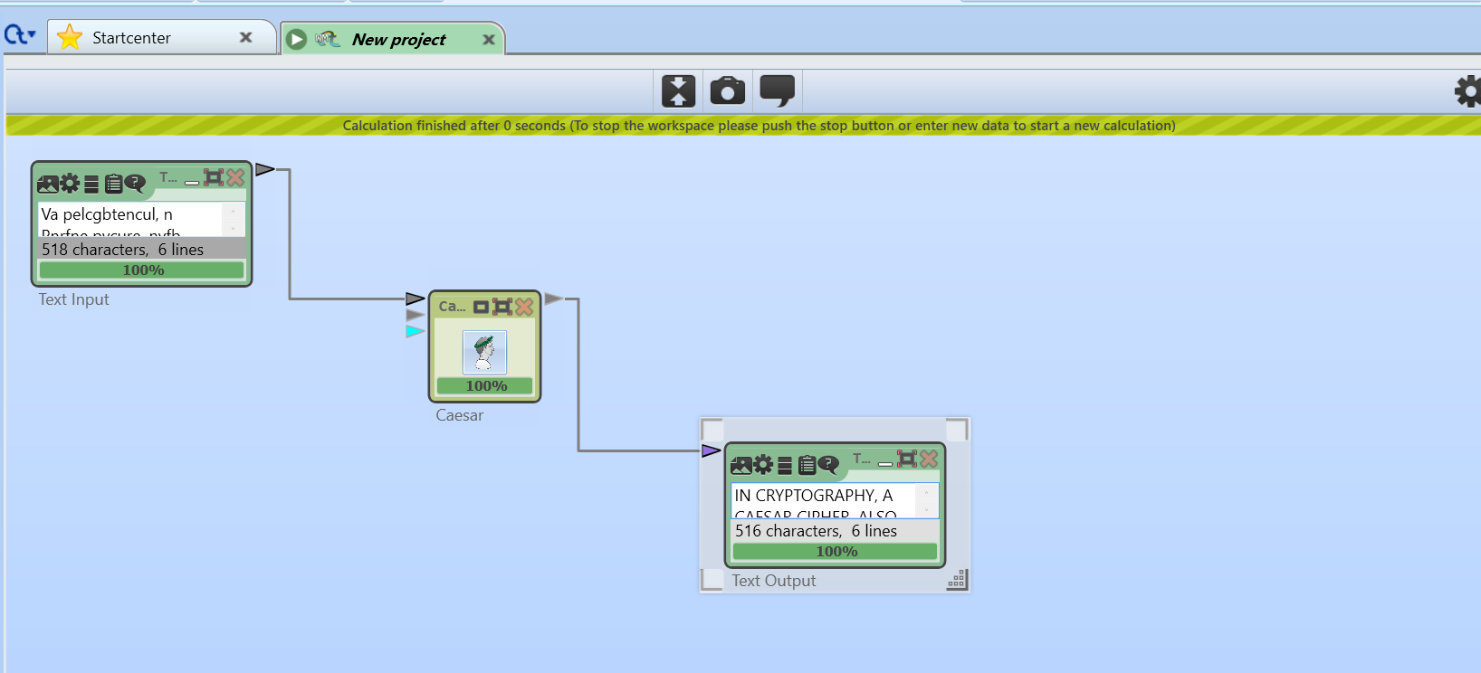
INPUT BEFORE DECRYPT:
Va pelcgbtencul, n Pnrfne pvcure, nyfb xabja nf Pnrfne'f pvcure, gur fuvsg pvcure, Pnrfne'f pbqr be Pnrfne fuvsg, vf bar bs gur fvzcyrfg naq zbfg jvqryl xabja rapelcgvba grpuavdhrf. Vg vf n glcr bs fhofgvghgvba pvcure va juvpu rnpu yrggre va gur cynvagrkg vf ercynprq ol n yrggre fbzr svkrq ahzore bs cbfvgvbaf qbja gur nycunorg. Sbe rknzcyr, jvgu n yrsg fuvsg bs 3, Q jbhyq or ercynprq ol N, R jbhyq orpbzr O, naq fb ba. Gur zrgubq vf anzrq nsgre Whyvhf Pnrfne, jub hfrq vg va uvf cevingr pbeerfcbaqrapr.
OUTPUT AFTER DECRYPT:
IN CRYPTOGRAPHY, A CAESAR CIPHER, ALSO KNOWN AS CAESAR'S CIPHER, THE SHIFT CIPHER, CAESAR'S CODE
OR CAESAR SHIFT, IS ONE OF THE SIMPLEST AND MOST WIDELY KNOWN ENCRYPTION TECHNIQUES. IT IS A TYPE
OF SUBSTITUTION CIPHER IN WHICH EACH LETTER IN THE PLAINTEXT IS REPLACED BY A LETTER SOME
FIXED NUMBER OF POSITIONS DOWN THE ALPHABET. FOR EXAMPLE, WITH A LEFT SHIFT OF 3, D WOULD BE
REPLACED BY A, E WOULD BECOME B, AND SO ON. THE METHOD IS NAMED AFTER JULIUS CAESAR, WHO USED
IT IN HIS PRIVATE CORRESPONDENCE.

TASK2:
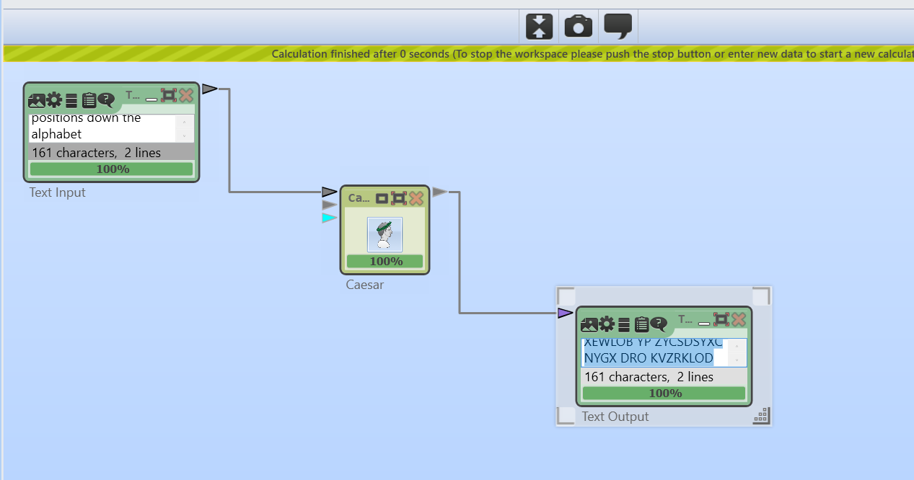
INPUT BEFORE ENCRYPT:
Ceaser Cipher is a type of substitution cipher in which each letter in the plaintext is
replaced by a letter some fixed number of positions down the alphabet
OUTPUT AFTER ENCRYPT:
MOKCOB MSZROB SC K DIZO YP CELCDSDEDSYX MSZROB SX GRSMR OKMR VODDOB SX DRO ZVKSXDOHD SC
BOZVKMON LI K VODDOB CYWO PSHON XEWLOB YP ZYCSDSYXC NYGX DRO KVZRKLOD

TASK 3:
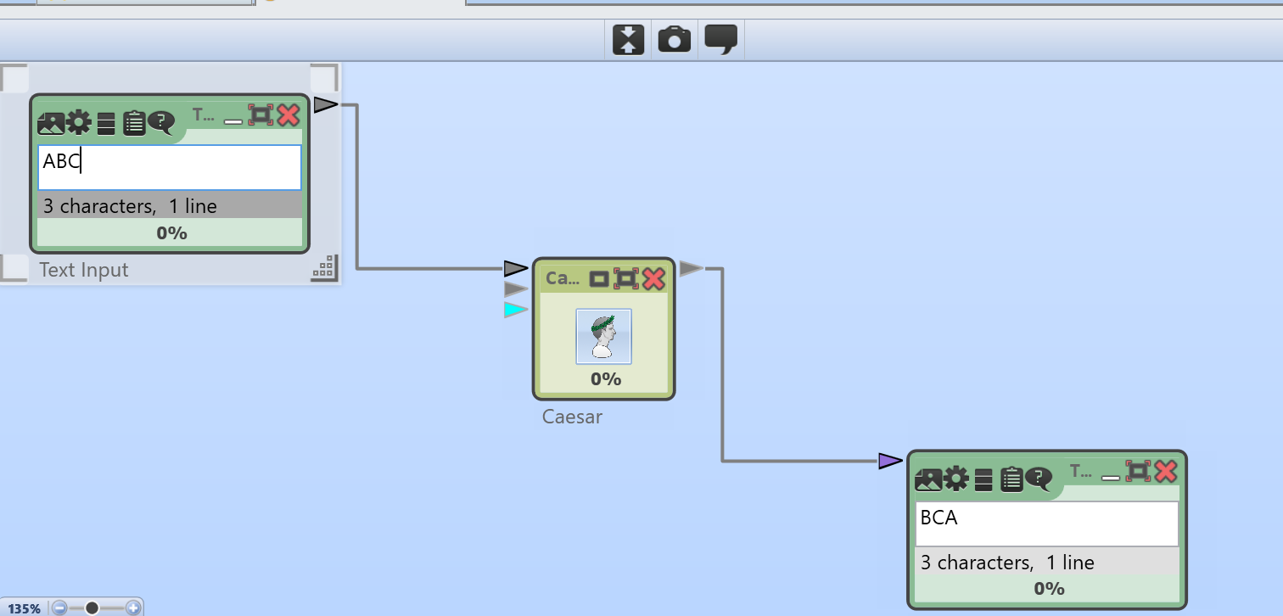
SETTINGS:
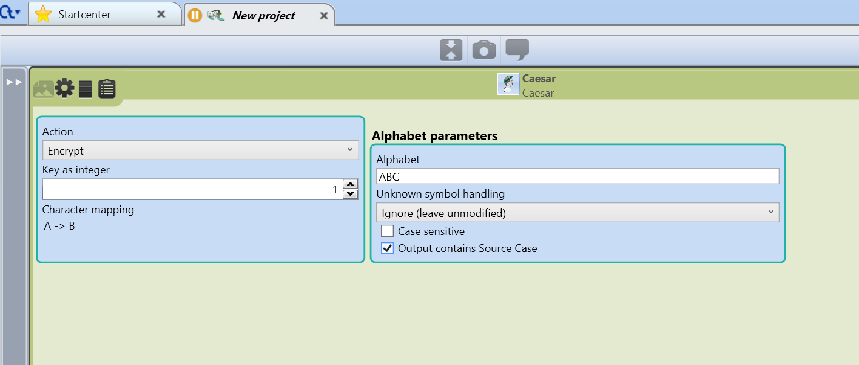

TASK 4:
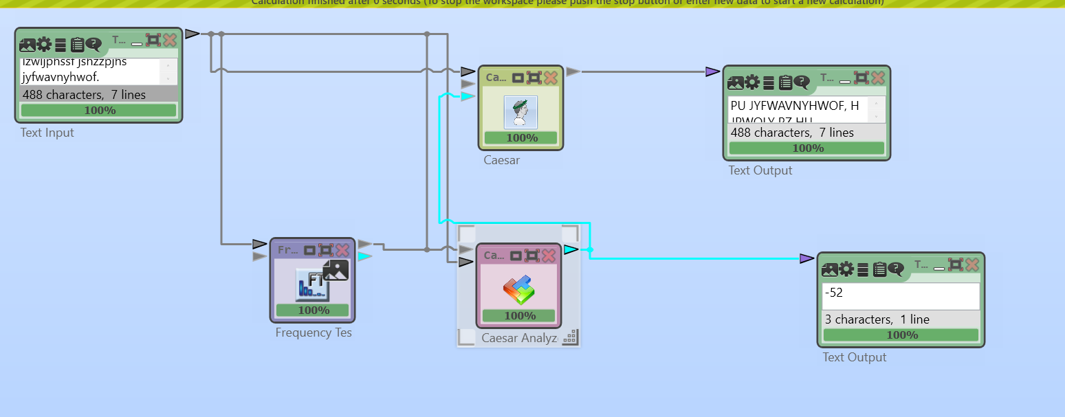
Unigram Frequency:
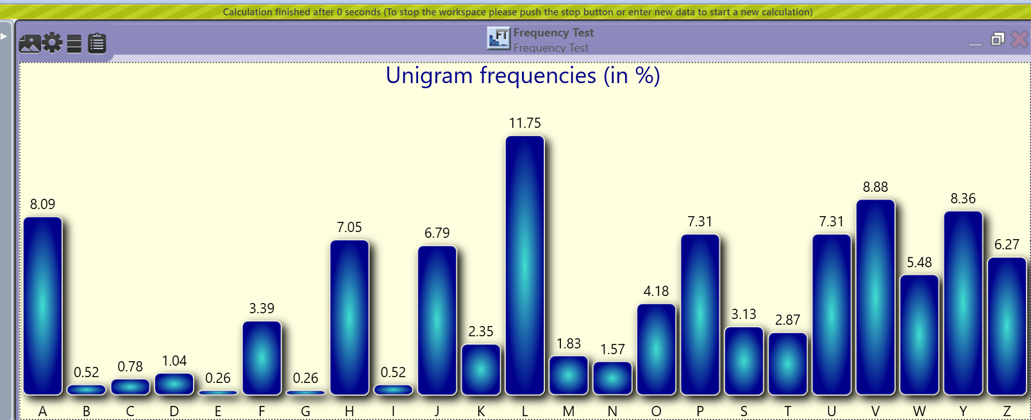
Graded Tak1:
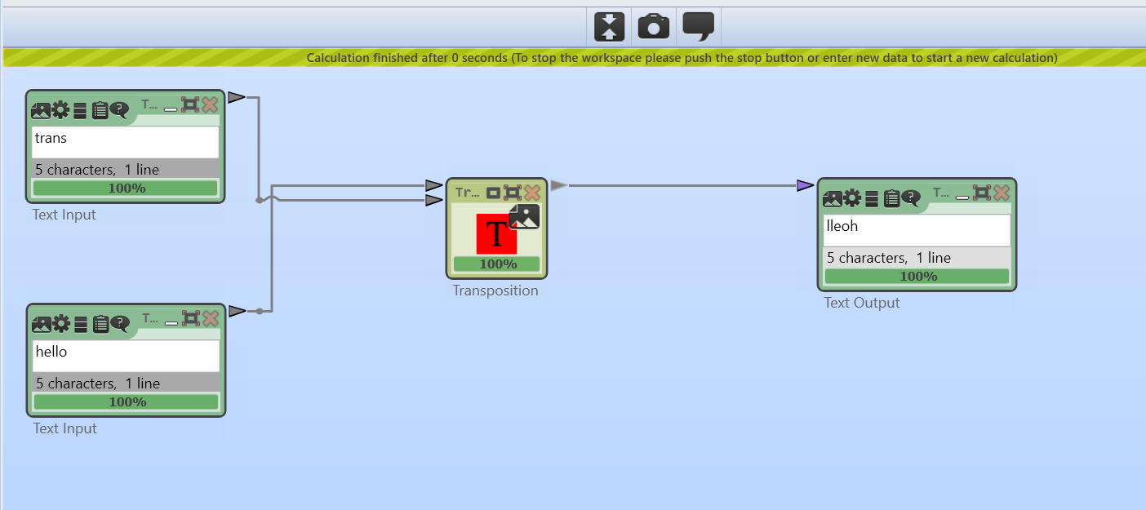

Cypher encryption using transposition Method.

Graded Task 2:
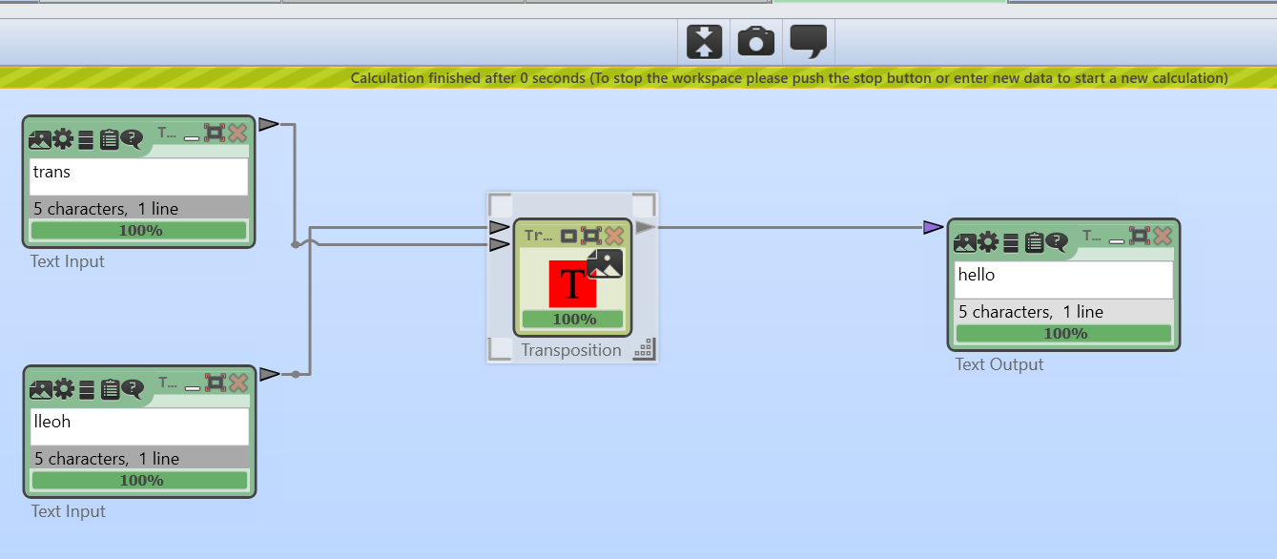

Cypher decryption

